MODULE 3
GEOMETRY OF VIRTUAL WORLD, VISUAL PERCEPTION

- The Geometry of Virtual Worlds
Virtual World Generator (VWG), maintains the geometry and physics of the virtual world. The geometry part is needed to make models and move them around. The models could include the walls of a building, furniture, clouds in the sky, the user’s avatar, and so on.
1.1 Geometric Models
We first need a virtual world to contain the geometric models. For our purposes, it is enough to have a 3D Euclidean space with Cartesian coordinates. Therefore, let denote the virtual world, in which every point is represented as a triple of real-valued coordinates: (x, y, z). The coordinate axes of our virtual world are shown in Figure 3.1.
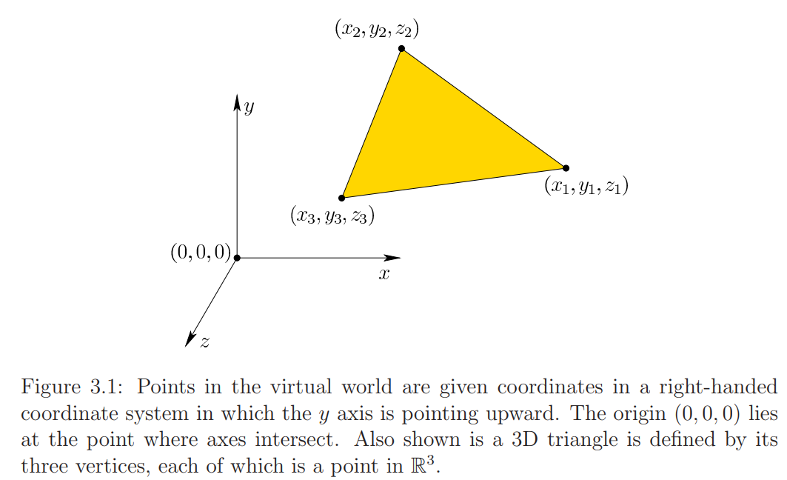
Here right-handed coordinate system is used.
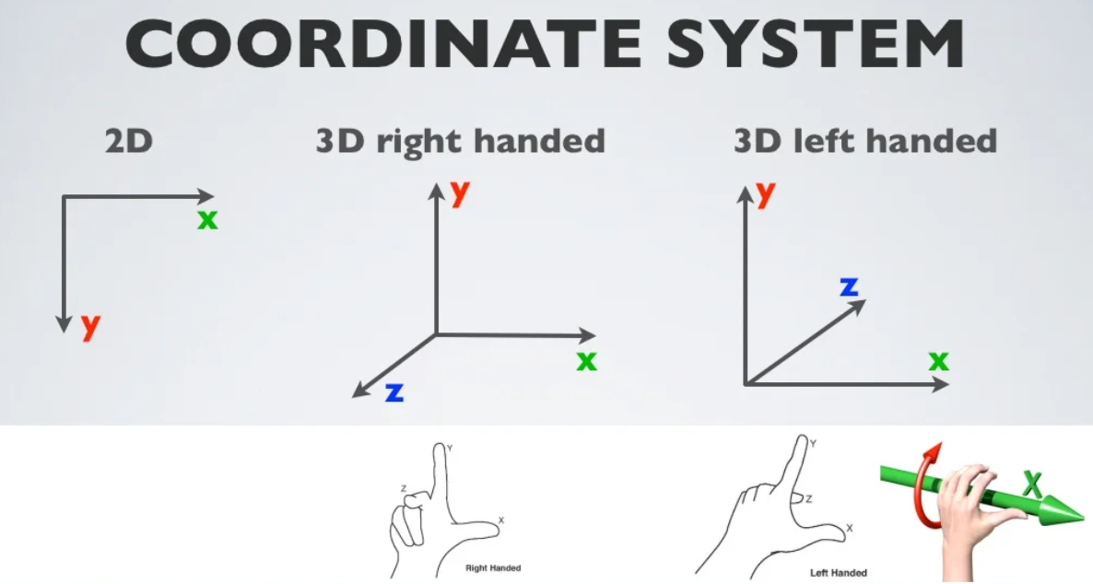
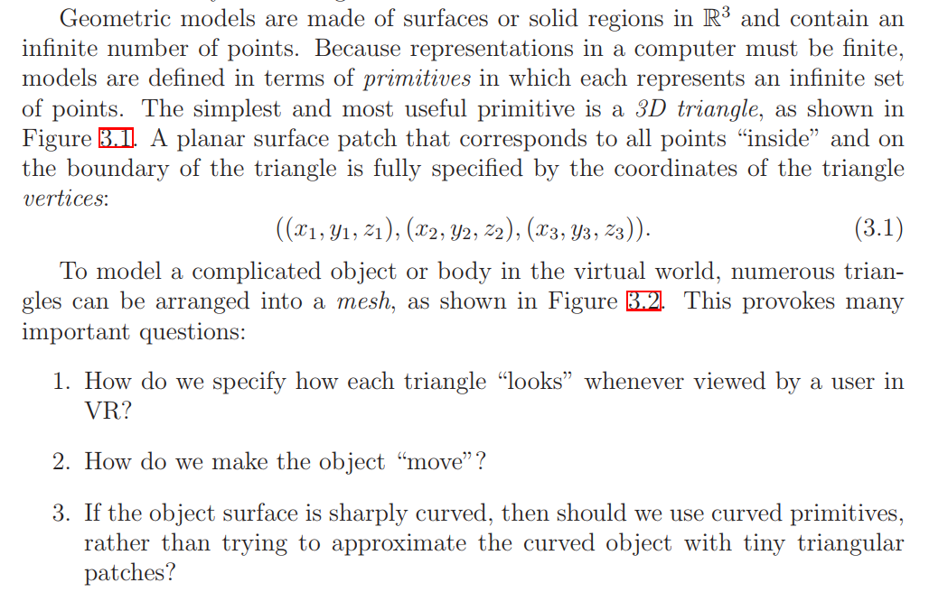
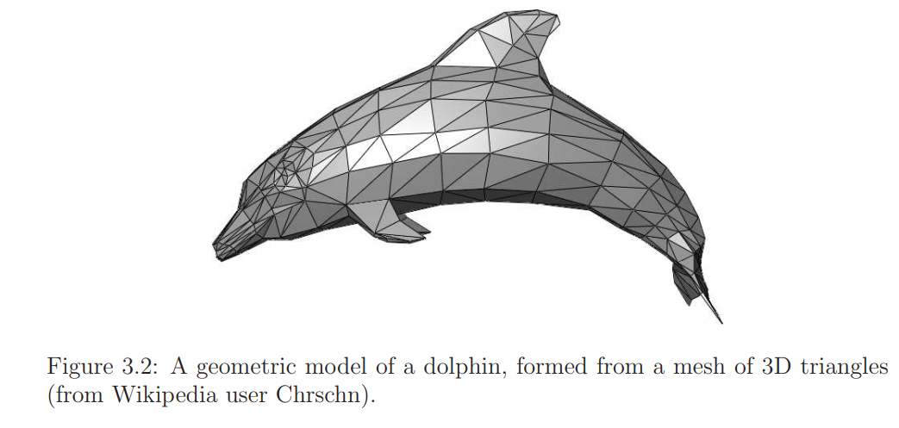
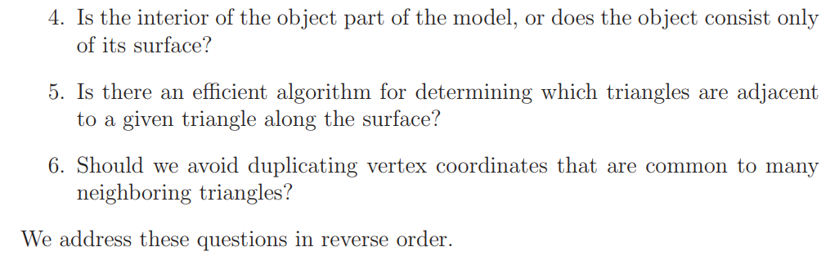
Data Structures
Geometric models are usually encoded in clever data structures. The choice of the data structure should depend on which operations will be performed on the model. One of the most useful and common is the doubly connected edge list, also known as half-edge data structure . See Figure 3.3.
DCEL is one of the most commonly used representations for planar subdivisions such as Voronoi diagrams. In this and similar data structures, there are three kinds of data elements or records:
- Face
- Edge
- Vertex.
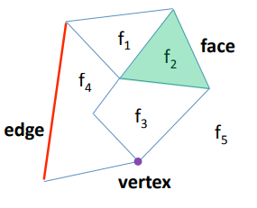Fig: planar subdivisions
These represent two, one, and zero-dimensional parts, respectively, of the model.
- In our case, every face element represents a triangle.
- Each edge represents the border of one or two triangles, without duplication.
- Each vertex is shared between one or more triangles, again without duplication.
- The data structure contains pointers between adjacent faces, edges, and vertices so that algorithms can quickly traverse the model components in a way that corresponds to how they are connected together.
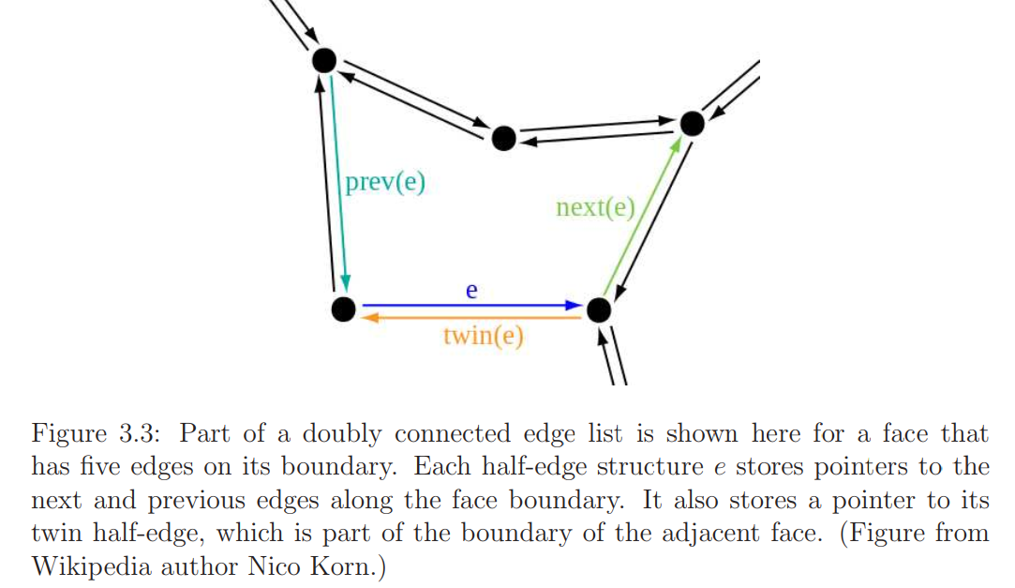
DCEL facilitates traversing the faces of planar subdivision, visiting all the edges around a given vertex.
– Edges are oriented counter clockwise inside each face
– Since an edge borders two faces, each edge is replaced by two half‐edges, one for each face
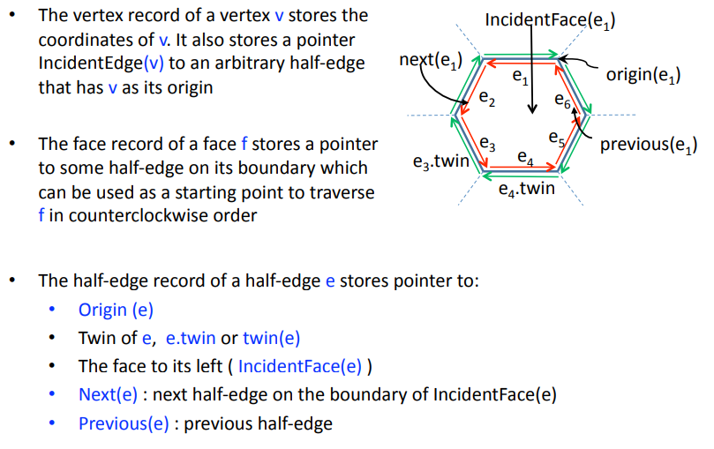
Inside vs. outside
Whether the object interior is part of the model?
Suppose the mesh triangles fit together perfectly so that every edge borders exactly two triangles and no triangles intersect unless they are adjacent along the surface. In this case, the model forms a complete barrier between the inside and outside of the object. If we were to hypothetically fill the inside with a gas, then it could not leak to the outside. This is an example of a coherent model. Such models are required if the notion of inside or outside is critical to the VWG.
If you are using a high-level design tool, such as Blender or Maya, to make your models, then coherent models will be automatically built.
Why triangles?
Triangles are used because they are the simplest for algorithms to handle, especially if implemented in hardware. It is certainly possible to use more complicated primitives, such as quadrilaterals, splines, and semi-algebraic surfaces .This could lead to smaller model sizes, but often comes at the expense of greater computational cost for handling each primitive. For example, it is much harder to determine whether two spline surfaces are colliding, in comparison to two 3D triangles.
Stationary vs. movable models
There will be two kinds of models in the virtual world, which is embedded in R3:
• Stationary models, which keep the same coordinates forever. Typical examples are streets, floors, and buildings.
• Movable models, which can be transformed into various positions and orientations. Examples include vehicles, avatars, and small furniture.
Motion can be caused in a number of ways. Using a tracking system the model might move to match the user’s motions. Alternatively, the user might operate a controller to move objects in the virtual world, including a representation of himself. Finally, objects might move on their own according to the laws of physics in the virtual world.
Choosing coordinate axes
If the virtual world is supposed to correspond to familiar environments from the real world, then the axis scaling should match common units. For example, (1, 0, 0) should mean one meter to the right of (0, 0, 0). It is also wise to put the origin (0, 0, 0) in a convenient location. Commonly, y = 0 corresponds to the floor of a building or sea level of a terrain. The location of x = 0 and z = 0 could be in the center of the virtual world so that it nicely divides into quadrants based on sign. Another common choice is to place it in the upper left when viewing the world from above so that all x and z coordinates are nonnegative. For movable models, the location of the origin and the axis directions become extremely important because they affect how the model is rotated.
Viewing the models
One of the most important aspects of VR is how the models are going to “look” when viewed on a display. This problem is divided into two parts.
- The first part involves determining where the points in the virtual world should appear on the display. This is accomplished by viewing transformations, which are combined with other transformations in to produce the final result.
- The second part involves how each part of the model should appear after taking into account lighting sources and surface properties that are defined in the virtual world. This is the rendering problem.
  - Changing Position and Orientation
Suppose that a movable model has been defined as a mesh of triangles. By combining translation and rotation, the model can be placed anywhere, and at any orientation in the virtual world
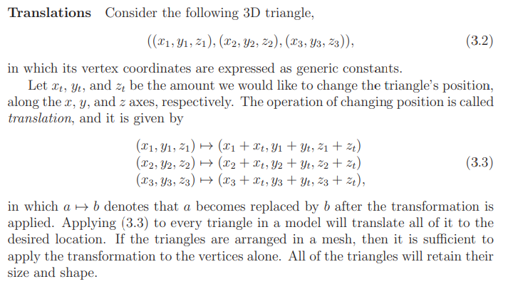
Relativity
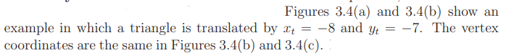
In Figure 3.4(b) the triangle is interpreted as having moved in the virtual world. However, Figure 3.4(c) shows another possibility: The coordinates of the virtual world have been reassigned so that the triangle is closer to the origin. This is equivalent to having moved the entire world, with the triangle being the only part that does not move. In this case, the translation is applied to the coordinate axes, but they are negated. Transforming the coordinate axes results in an inverse of the transformation that would correspondingly move the model. Negation is simply the inverse in the case of translation.
Thus, we have a kind of “relativity”: Did the object move, or did the whole world move around it?
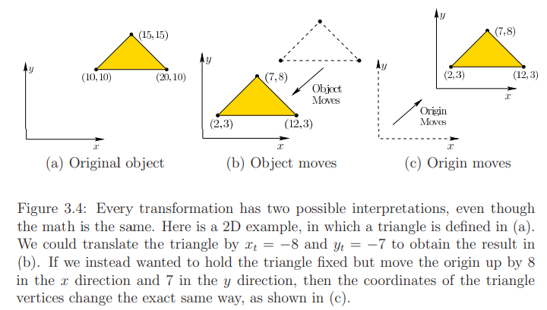
Getting ready for rotations
How do we make the wheels roll on a car? Or turn a table over onto its side? To accomplish these, we need to change the model’s orientation in the virtual world. The operation that changes the orientation is called rotation.
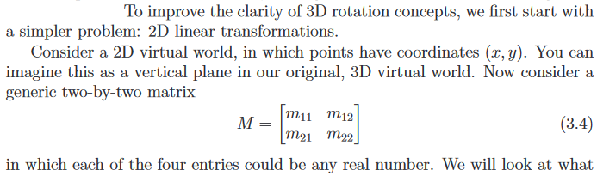
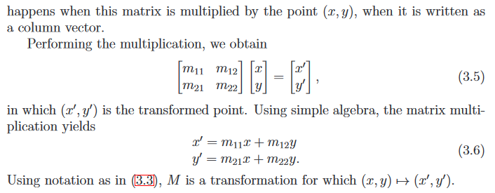
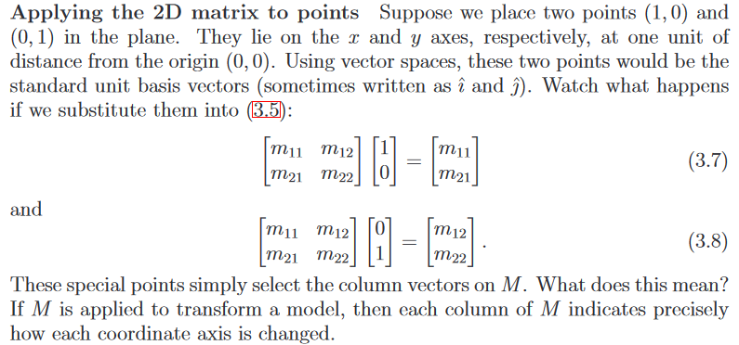
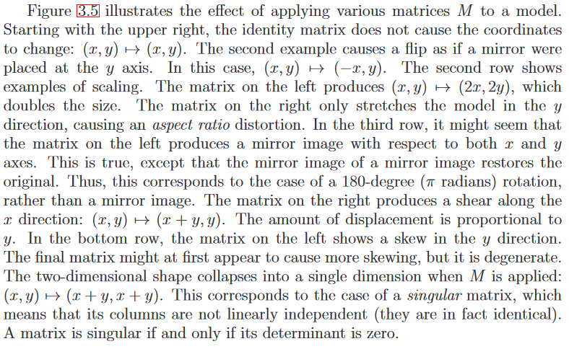
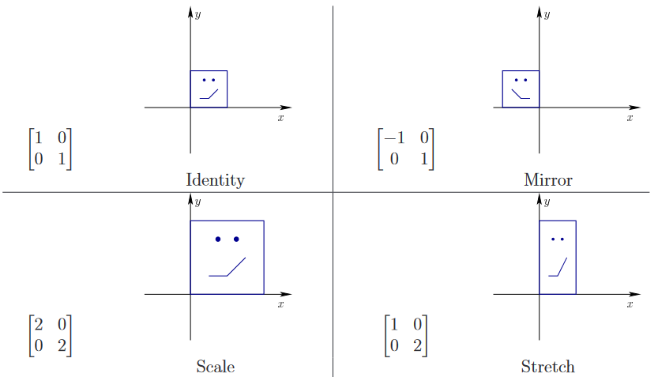
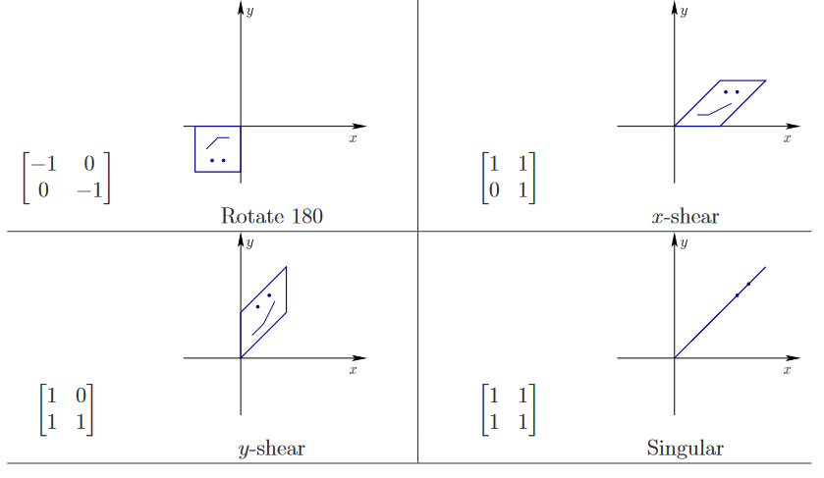
Figure 3.5: Eight different matrices applied to transform a square face. These examples nicely cover all of the possible cases, in a qualitative sense.

Only some matrices produce rotations
All the transformations not necessary lead to rotation of points considered in the 3D virtual world. The identity matrix, which is 0 degrees of rotation, and the 180-degree rotation matrix is only needed.
Among set of all possible transformation, certain rules are to be followed to achieve rotation.
- No stretching of axes
- No shearing
- No mirror images
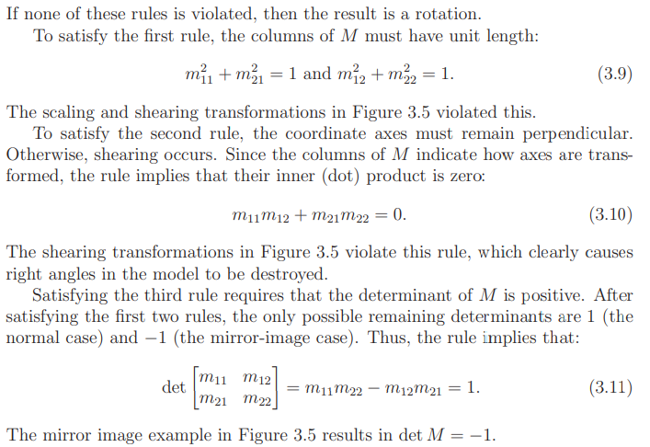
In standard planar coordinates, we commonly write the equation of this circle as x² + y² = 1.
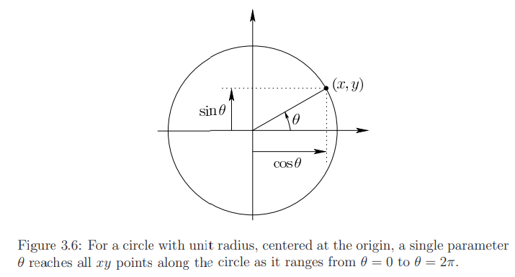
In figure 3.6,
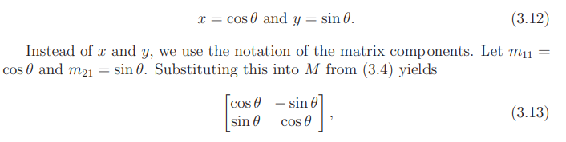
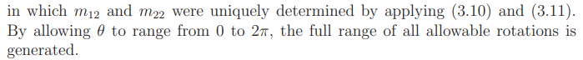
Consider degrees of freedom.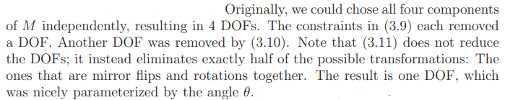
The 3D case
Consider the set of all 3D rotations.
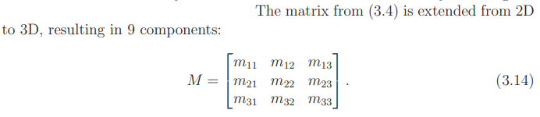
Yaw, pitch, and roll
Any three dimensional rotations can be described as a sequence of yaw, pitch, and roll rotations.
- RollRoll is a counterclockwise rotation of about the z-axis. The rotation matrix is given by:
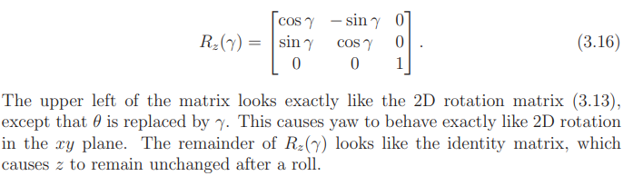
The matrix for rotation about the Z axis contains a 2D rotation matrix in its upper corner.
- Pitch Pitch is a counter clockwise rotation of about the x - axis. The rotation matrix is given by:
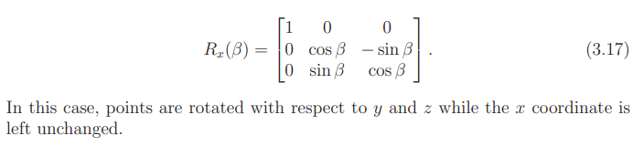
- Yaw Yaw is a counter clockwise rotation of about the y - axis. The rotation matrix is given by:
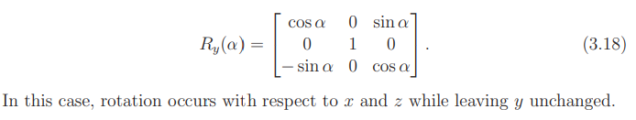
The reason why the −sinθ term switches to below the diagonal is that if one were to orient a frame so the Y axis points out of the page, and align the X axis to point rightward, the Z axis would point downward instead of upward. Instead, the matrix can be derived by aligning the Z axis to the rightward direction and the X axis to the upward direction, so that the -sinθ
term arrives in the Z,X spot.
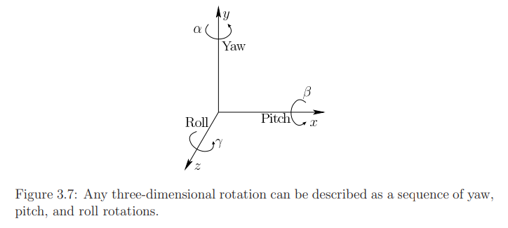
Combining Rotations
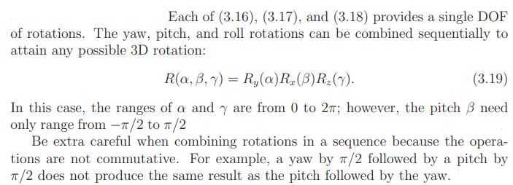
The 2D case is commutative because the rotation axis is always the same, allowing the rotation angles to additively combine.
Matrix multiplications are “backwards”
Which operation is getting applied to the model first when we apply a product of matrices?
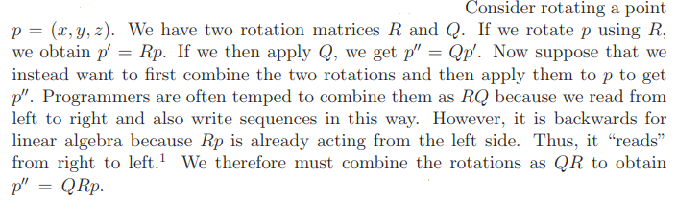
Translation and rotation in one matrix
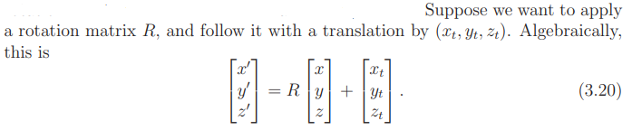
To apply both rotation and translation in a single operation, 4 by 4 homogeneous transformation matrix is used.
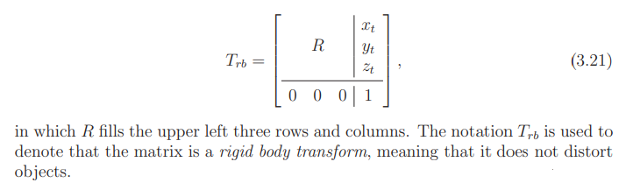
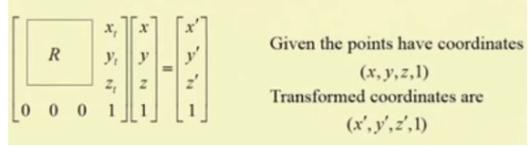 (3.22)
Inverting Transforms
For a general matrix transform M, we apply the matrix inverse M⁻¹ .
In the case of a rotation matrix R, the inverse is equal to the transpose, R⁻¹ = R ^{T}.
To invert the homogeneous transform matrix , it is tempting to write
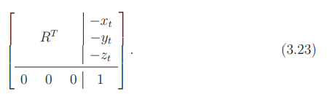
This will undo both the translation and the rotation; however, the order is wrong because the operations are not commutative.
In algebra it states that the inverse of a product of matrices reverses their order.
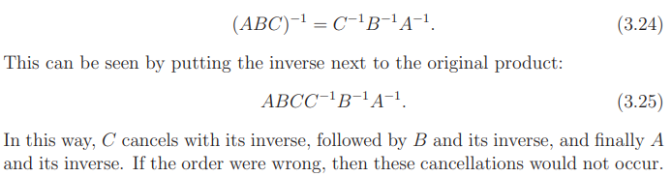
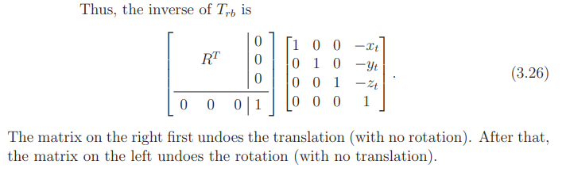
  - Axis-Angle Representations of Rotations
3D rotation is complicated for several reasons:
1) Nine matrix entries are specified in terms of only three independent parameters, and with no simple parameterization,
2) the axis of rotation is not the same every time, and
3) the operations are noncommutative, implying that the order of matrices is crucial.
Kinematic singularities
Here is how it looks when combining the yaw, pitch, and roll matrices:
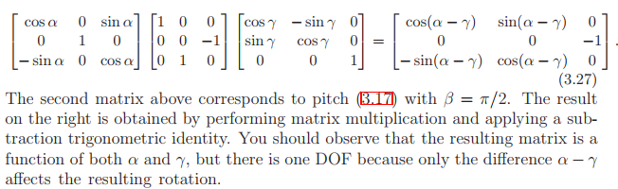
A robot’s DoF is the number of independently controllable joints it has. So, a 6 DoF robot — as most industrial robots are — has 6 independently movable joints. When a 6 DoF robot enters a singularity, one or more of its joints will effectively become useless, turning it into a 4 or 5 DoF robot.
A kinematic singularity is a point that a robot cannot reach despite the absence of obstacles, but that is enclosed by points that it can reach.
This problem can be easily solved with axis-angle representations of rotation.
The most important insight to solving the kinematic singularity problems is Euler’s rotation theorem, shown in Figure 3.9. All 3D rotations have what is called an axis-angle representation. Even though the rotation axis may change after rotations are combined, Euler showed that any 3D rotation can be expressed as a rotation θ about some axis that pokes through the origin. The rotation θ describes the orientation of the body.
Ie if I consider the orientation of a rigid body in space, no matter what orientation it can have, I can describe that as a single rotation about some axis through the origin. And I could just turn the axis in the opposite direction and rotate by a negative amount and I will get the same result.( It is one annoying problem with Euler’s rotation theorem).
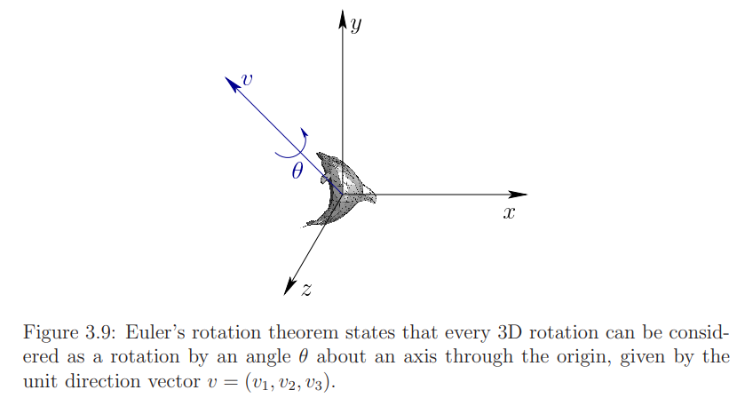
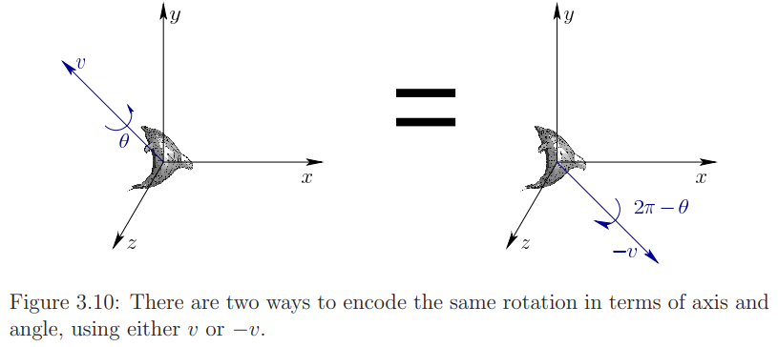
The only trouble is that conversions back and forth between rotation matrices and the axis-angle representation are somewhat inconvenient.
This motivates the introduction of a mathematical object that is close to the axis-angle representation, Quaternions.
Quaternions were introduced in 1843 by William Rowan Hamilton.
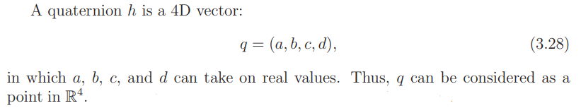Unit quaternions means
must always hold.
We will use the space of unit quaternions to represent the space of all 3D rotations.
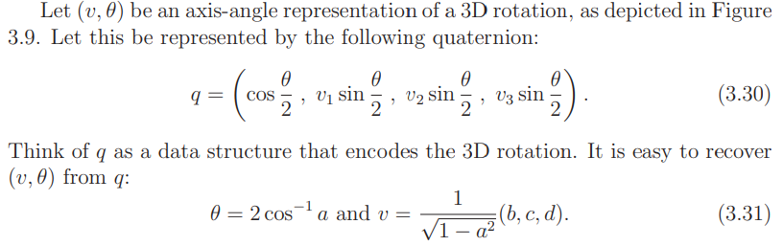
Figure 3.11 shows some simple examples, which commonly occur in practice.
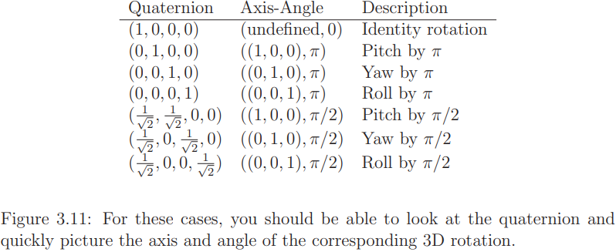
Figure 3.12 shows some simple relationships between quaternions and their corresponding rotations.
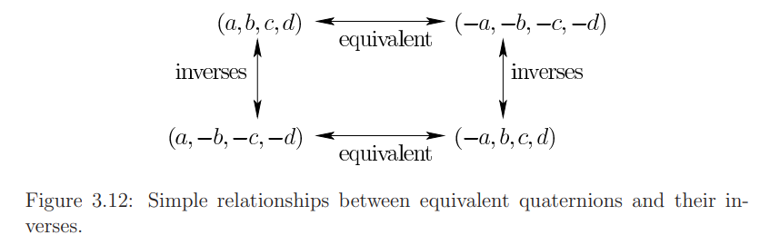
The horizontal arrows indicate that q and −q represent the same rotation. This is true because of the double representation issue shown in Figure 3.10. The vertical arrows correspond to inverse rotations. These hold because reversing the direction of the axis causes the rotation to be reversed (rotation by θ becomes rotation by 2π − θ).
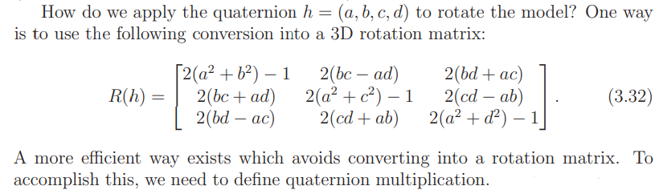
1.4 Viewing Transformations
This section describes how to transform the models in the virtual world so that they appear on a virtual screen. The main purpose is to set the foundation for graphical rendering, which adds effects due to lighting, material properties, and quantization.
Viewing Transformation is the mapping of coordinates of points and lines that form the picture into appropriate coordinates on the display device.
An eye’s view (Express eye’s rotation and translation in the world)
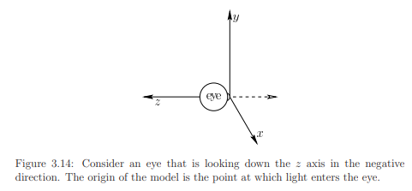
Figure 3.14 shows a virtual eye that is looking down the negative z axis. It is placed in this way so that from the eye’s perspective, x increases to the right and y is upward.
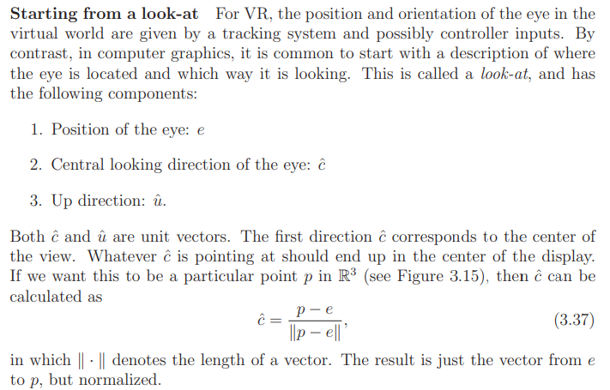
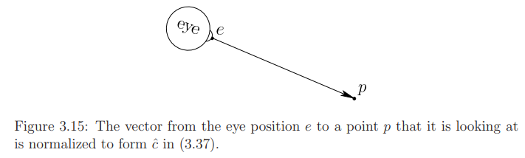
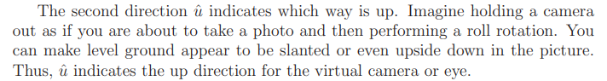
Therefore coordinate axes for eye in the world is calculated as OR
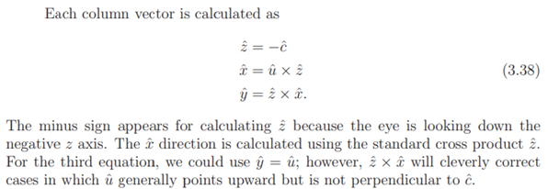
Therefore,
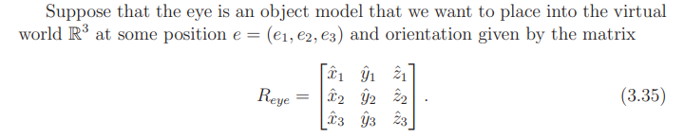
This does not, however, solve the problem of how the virtual world should appear to the eye. Rather than moving the eye in the virtual world, we need to move all of the models in the virtual world to the eye’s frame of reference.(ie if head is moved to left; the virtual world should move to right).
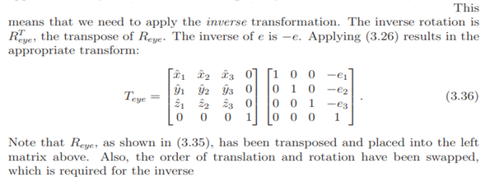
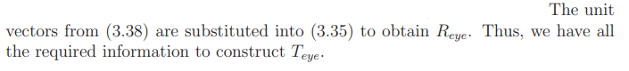
Orthographic projection
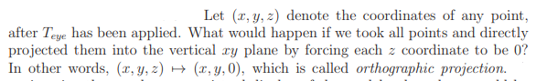 Orthographic projection is a common method of representing three-dimensional objects, usually by three two-dimensional drawings (top,front,side) in each of which the object is viewed along parallel lines that are perpendicular to the plane of the drawing.
If we imagine the xy plane as a virtual display of the models, then there would be several problems:
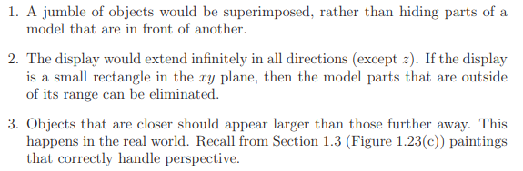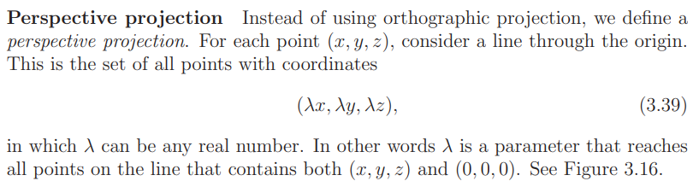
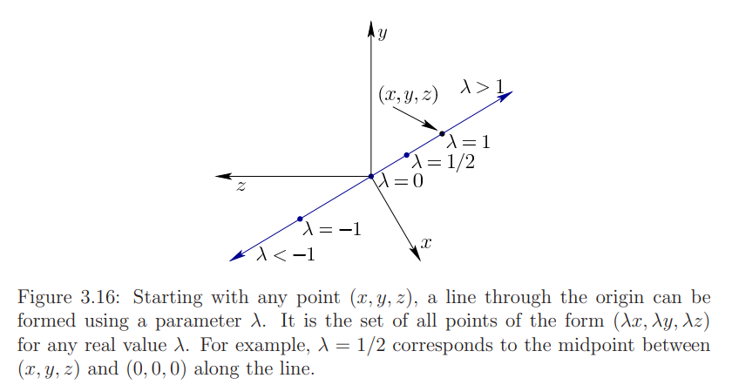
Now we can place a planar “movie screen” anywhere in the virtual world and see where all of the lines pierce it. To keep the math simple, let us pick the z = −1 plane to place our virtual screen directly in front of the eye; see Figure 3.17. Using
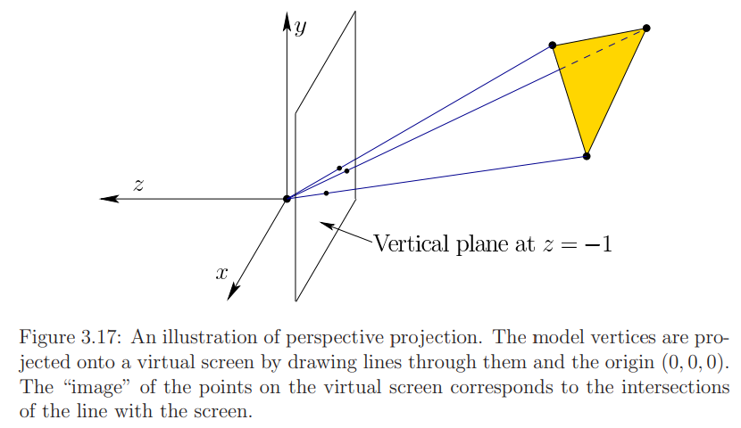
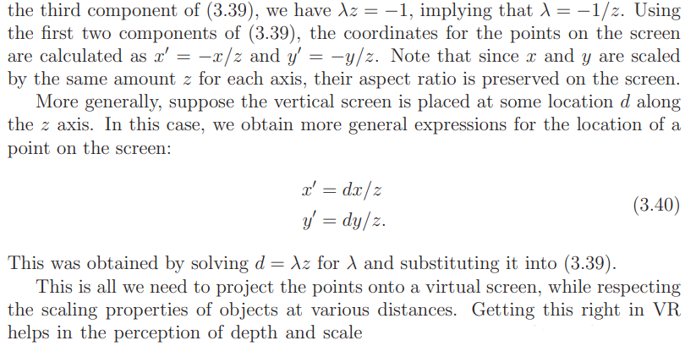
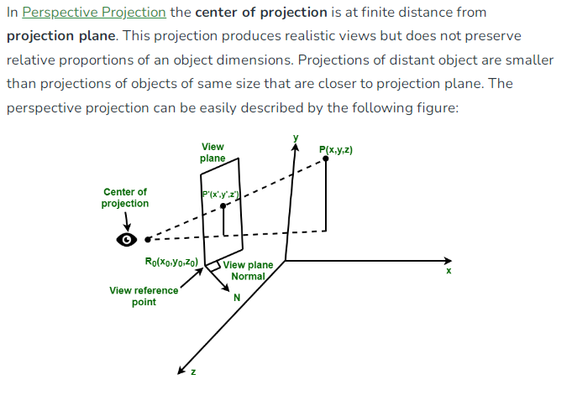
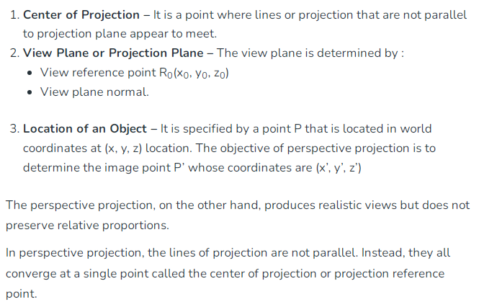
1.5 Chaining The Transformations
The chain of transformations generally appears as follows:
- When T is applied to a point (x, y, z, 1), the location of the point on the screen is produced.
- All of these matrix multiplications are not commutative, and the operations are applied from right to left.
- The first matrix T_{rb} is the rigid body transform (3.23) applied to points on a movable model. For each rigid object in the model, T_{rb} remains the same; however, different objects will generally be placed in various positions and orientations. For example, the wheel of a virtual car will move differently than the avatar’s head.
- After T_{rb} is applied, T_{eye} transforms the virtual world into the coordinate frame of the eye, according to (3.36). Here we assume that the eye is positioned at the midpoint between the two virtual human eyes, leading to a cyclopean viewpoint.
Canonical view transform
The next transformation, T_{can} performs the perspective projection. We want the result to be in a canonical form that appears to be unitless, which is motivated by industrial needs. Therefore, T_{can} is called the canonical view transform.
Figure 3.18 shows a viewing frustum, which is based on the four corners of a rectangular virtual screen.
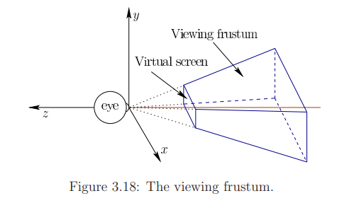
At z = n and z = f lie a near plane and far plane, respectively. Note that z < 0 for these cases because the z axis points in the opposite direction. The virtual screen is contained in the near plane. The perspective projection should place all of the points inside of the frustum onto a virtual screen that is centered in the near plane. This implies d = n using (3.40).
We now want to reproduce (3.40) using a matrix. Consider the result of applying the following matrix multiplication:
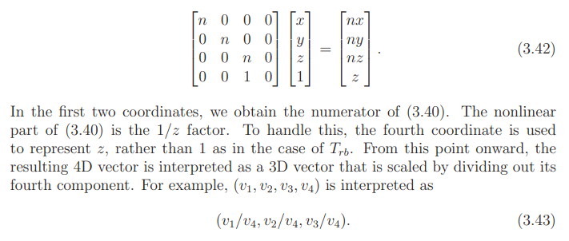
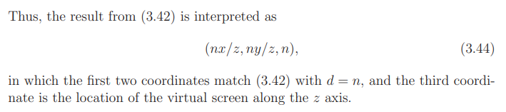

Keeping track of depth for later use
The following matrix is commonly used in computer graphics
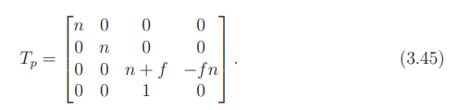
It is identical to the matrix in (3.42) except in how it transforms the z coordinate. For purposes of placing points on the virtual screen, it is unnecessary because we already know they are all placed at z = n. The z coordinate is therefore co-opted for another purpose: Keeping track of the distance of each point from the eye so that graphics algorithms can determine which objects are in front of other objects. The matrix T_{p} calculates the third coordinate as
When divided by z, (3.46) does not preserve the exact distance, but the graphics methods require only that the distance ordering is preserved. In other words, if point p is further from the eye than point q, then it remains further after the transformation, even if the distances are distorted. It does, however, preserve the distance in two special cases: z = n and z = f.
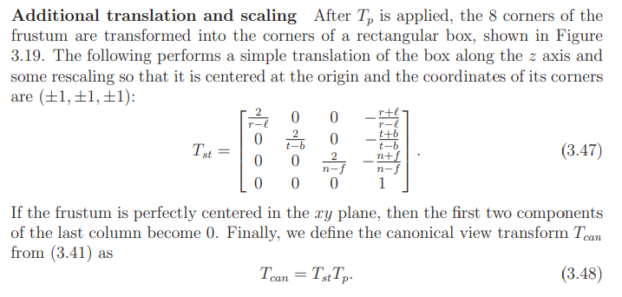
Perspective translation , T_{P} is done fist. Then scaling and translation transform, T_{st}.
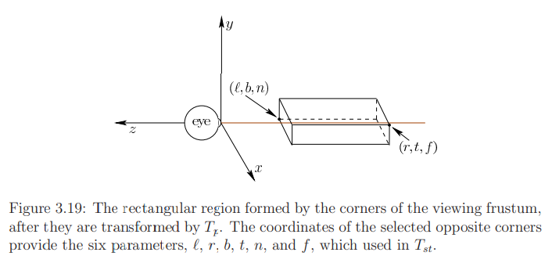
Viewport transform
After T_{can} has been applied, the x and y coordinates each range from −1 to 1. One last step is required to bring the projected points to the coordinates used to index pixels on a physical display. Let m be the number of horizontal pixels and n be the number of vertical pixels. For example, n = 1080 and m = 1920 for a 1080p display. Suppose that the display is indexed with rows running from 0 to n − 1 and columns from 0 to m − 1. Furthermore, (0, 0) is in the lower left corner. In this case, the viewport transform is
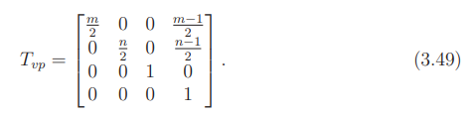
Left and right eyes
Here we address how the transformation chain (3.41) is altered for stereoscopic viewing.
Let t denote the distance between the left and right eyes. Its value in the real world varies across people, and its average is around t = 0.064 meters. To handle the left eye view, we need to simply shift the cyclopean (center) eye horizontally to the left. ie the inverse is actually got applied. The models need to be shifted to the right. That means we are adding a component t/2 to the x coordinate. Therefore, let
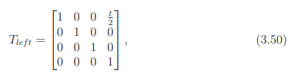
this corresponds to a right shift of the models, when viewed from the eye. This transform is placed after T_{eye} to adjust its output. The appropriate modification to (3.41) is:
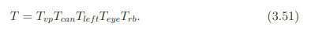
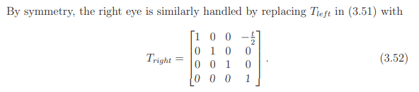
Here we are deducting a component t/2 to the x coordinate.
2.Visual Perception
2.1 Perception of Depth
Depth perception is your ability to see objects in three dimensions, including their size and how far away they are from you.
This section explains how humans judge the distance of objects from their eyes.
- The perceived distance could be metric, which means that an estimate of the absolute distance is obtained. For example, a house may appear to be about 100 meters away.
- Alternatively, the distance information could be ordinal, which means that the relative arrangement of visible objects can be inferred. For example, one house appears to be closer than another if it is partially blocking the view of the further one.
Monocular vs. stereo cues
A piece of information that is derived from sensory stimulation and is relevant for perception is called a sensory cue or simply a cue.
If a depth cue is derived from the photoreceptors or movements of a single eye, then it is called a monocular depth cue. If both eyes are required, then it is a stereo depth cue.
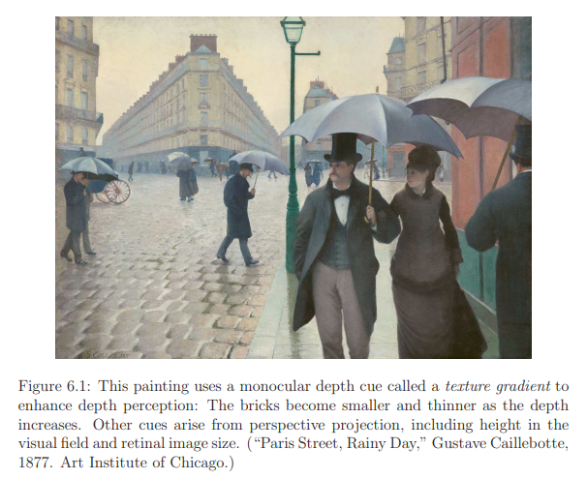
Texture Gradient-Objects near camera have more detailed pattern compared to objects that are further away.
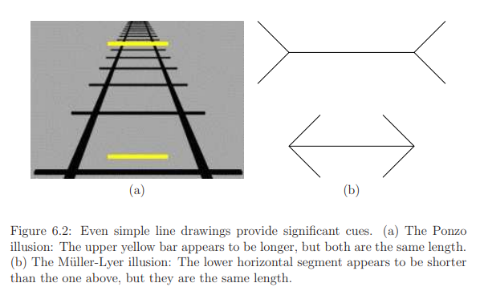
The illusions in Figure 6.2 show that even simple line drawings are enough to provide strong cues.
2.1.1 Monocular Depth Cues
Retinal Image Size
- We often judge the distance of an object by how “large” is appears to be.
- The size of the image on the retina is proportional to 1/z, in which z is the distance from the eye (or the common convergence point for all projection lines).
- The same thing happens when taking a picture with a camera: A picture of a basketball would occupy larger part of the image, covering more pixels, as it becomes closer to the camera. This cue is called retinal image size.(Figure 3.6)
- The retinal image size of a familiar object is a strong monocular depth cue.
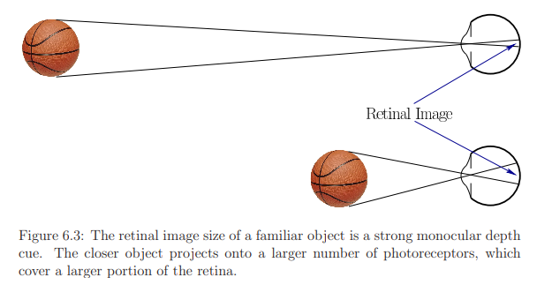
Size Constancy is the tendency to perceive an object as being the same size regardless of whether it is close or far away. (ie see and recognize an object as being the same despite the fact that image of the object in our retina changes continuously. For example when we look at a car that drives away from us, the size of the car in our retina is going to be smaller and smaller as the distance increases nevertheless we do not see the car as shrinking to a small toy. But we recognize the car as being further away. )This happens in the case of familiar objects. A simpler example is considering how people perceive doors on a day-to-day basis. People perceive the sizes of doors to be constant no matter the distance they observe the door from.
Size constancy falls of the general heading of subjective constancy.
If there is significant uncertainty about the size of an object, then knowledge of its distance should contribute to estimating its size. This falls under size perception, which is closely coupled to depth perception.
One controversial theory is that our perceived visual angle differs from the actual visual angle. The visual angle is proportional to the retinal image size. This theory is used to explain the illusion that the moon appears to be larger when it is near the horizon. For another example, see Figure 6.4.
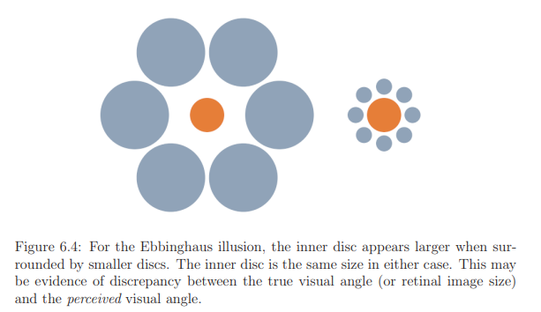
Height in the visual field
Distant objects tend to appear higher than closer objects.
Figure 6.5(a) illustrates another important cue, which is the height of the object in the visual field. Suppose that we can see over a long distance without obstructions. Due to perspective projection, the horizon is a line that divides the view in half. The upper half is perceived as the sky, and the lower half is the ground. The distance of objects from the horizon line corresponds directly to their distance due to perspective projection: The closer to the horizon, the further the perceived distance. Size constancy scaling, if available, combines with the height in the visual field, as shown in Figure 6.5(b).
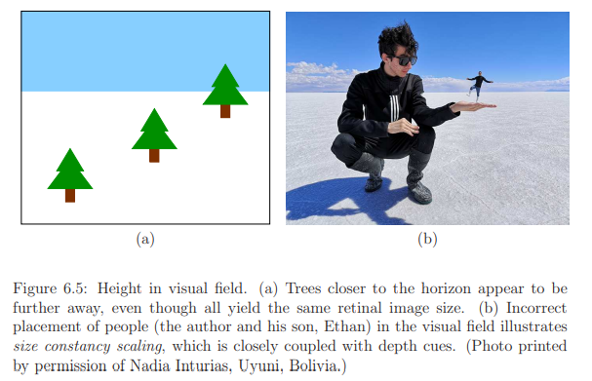

Accommodation
The human eye lens can change its optical power through the process of accommodation. For young adults, the amount of change is around 10D (diopters), but it decreases to less than 1D for adults over 50 years old. The ciliary muscles control the lens and their tension level is reported to the brain through efference copies of the motor control signal. This is the first depth cue that does not depend on signals generated by the photoreceptors.
Motion parallax
If you have ever looked out of the side window of a fast-moving vehicle, you might have noticed that the nearby objects race by much faster than further objects. The relative difference in speeds is called parallax.
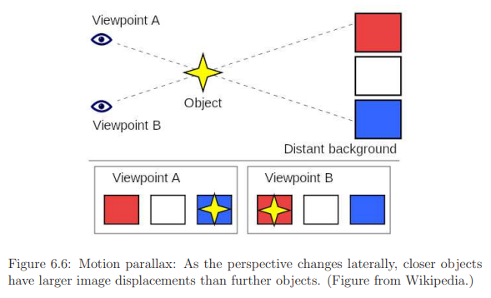
Closely related to motion parallax is optical flow, which is a characterization of the rates at which features move across the retina.
Other monocular cues
Figure 6.7 shows several other monocular cues. As shown in Figure 6.7(a), shadows that are cast by a light source encountering an object provide an important cue. Figure 6.7(b) shows a simple drawing that provides an ordinal depth cue called interposition by indicating which objects are in front of others. Figure 6.7(c) illustrates the image blur cue, where levels are depth are inferred from the varying sharpness of focus. Figure 6.7(d) shows an atmospheric cue in which air humidity causes far away scenery to have lower contrast, thereby appearing to be further away.
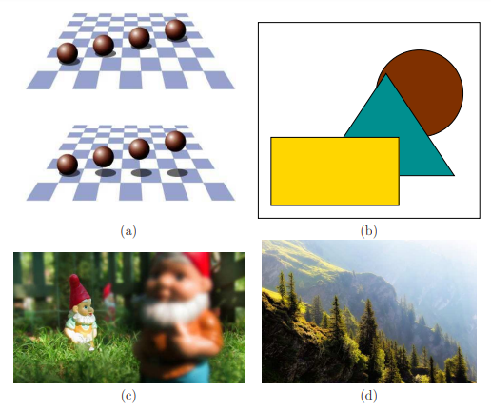
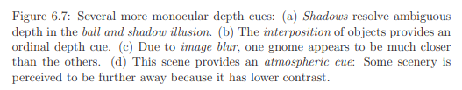
2.1.2 Stereo Depth Cues
Humans perceive a single focused image over a surface in space called the horopter.
Each eye provides a different viewpoint, which results in different images on the retina. This phenomenon is called binocular disparity.
Diplopia is defined as seeing two images of a single object when you're looking at it.

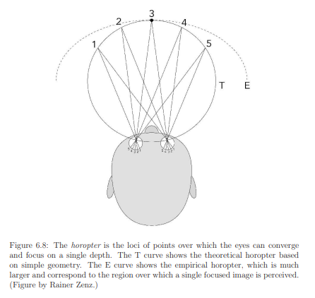
2.1.3 Implications for VR
Incorrect scale perception
A virtual world may be filled with objects that are not familiar to us in the real world. In many cases, they might resemble familiar objects, but their precise scale might be difficult to determine. Consider the Tuscany demo world from Oculus VR, shown in Figure 6.9.
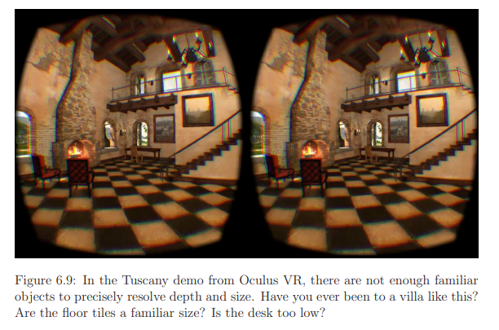
- The virtual villa is designed to be inhabited with humans, but it is difficult to judge the relative sizes and distances of objects because there are not enough familiar objects.
- Further complicating the problem is that the user’s height in VR might not match his height in the virtual world. Is the user too short, or is the world too big?
- A common and confusing occurrence is that the user might be sitting down in the real world, but standing in the virtual world.
- An additional complication occurs if the interpupillary distance is not matched with the real world. For example, if the user’s pupils are 64mm apart in the real world but only 50mm apart in the virtual world, then the virtual world will seem much larger, which dramatically affects depth perception.
- Likewise, if the pupils are very far apart, the user could either feel enormous or the virtual world might seem small.
- Imagine simulating a Godzilla experience, where the user is 200 meters tall and the entire city appears to be a model.
Mismatches
Figure 6.10 shows an elaborate illusion that requires building a distorted room in the real world. It is perfectly designed so that when viewed under perspective projection from one location, it appears to be a rectangular box. Once our brains accept this, we unexpectedly perceive the size of people changing as they walk across the room! This is because all of the cues based on perspective appear to be functioning correctly.
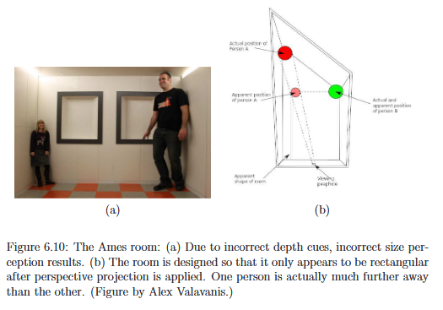
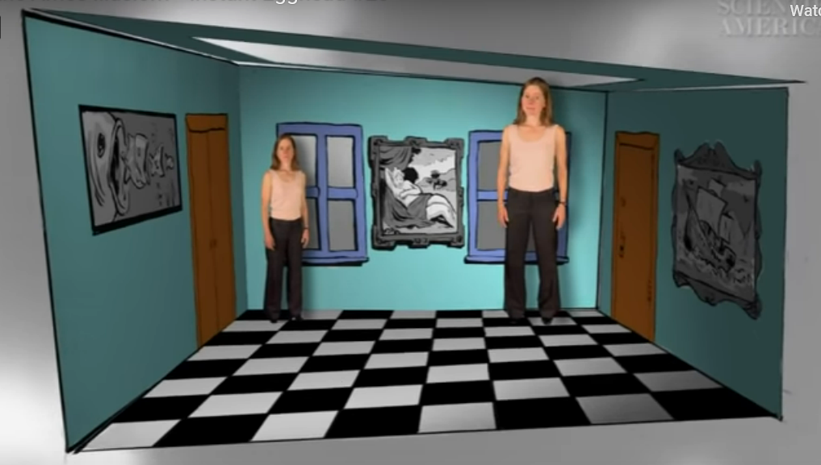
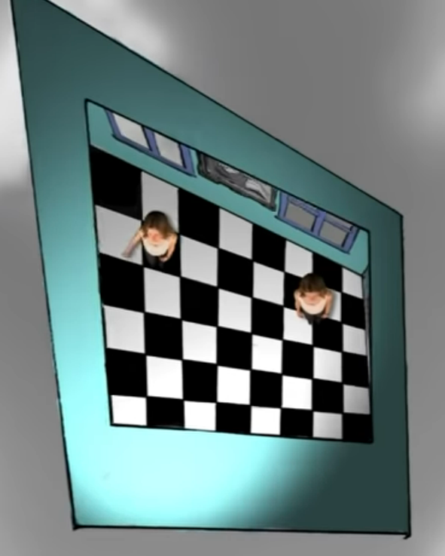
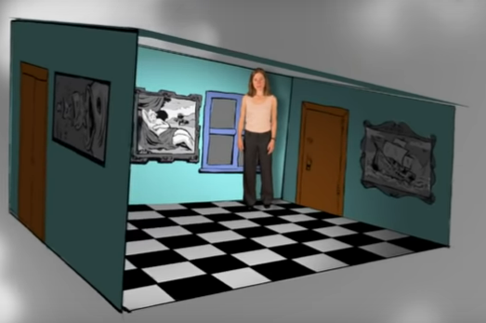
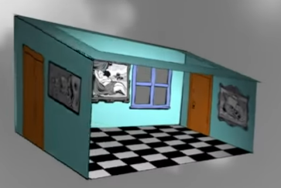
The room’s features are cleverly distorted to be consistent with a rectangular shape , but it is actually trapezoidal. The back left corner of the room is much farther away from the right. So the person standing there seems smaller. The ceiling cue is also misleading. The floor actually slants upward and ceiling downward from left to right making head much closer to the ceiling. The checkerboard pattern on the floor gets finer grain towards the light, so that the same number of pattern elements fit in a shorter distance. The windows are resized and shaped to match the trapezoidal back wall. Viewer’s narrow angle of view from the front of the room blocks the cues that will reveal the room’s true shape and of course people believe in a box shape because that’s the shape rooms normally are. This clever set-up is called the Ames illusion
To preserve most depth cues based on motion, it is important to track head position, in addition to orientation.
Monocular cues are powerful
A common misunderstanding among the general public is that depth perception enabled by stereo cues alone. But actually there are many more monocular depth cues than stereo cues.
2.2 Perception of Motion
We rely on our vision to perceive motion. One use is to separate a moving figure from a stationary background. For example, a camouflaged animal in the forest might only become noticeable when moving. This is clearly useful whether humans are the hunter or the hunted.
Motion also helps people to assess the 3D structure of an object. Imagine assessing the value of a piece of fruit in the market by rotating it around.
As the perception of motion is the perception of non-motion, which we called perception of stationarity.
2.2.1 Detection Mechanisms
Reichardt detector
Figure 6.12 shows a neural circuitry model, called a Reichardt detector, which responds to directional motion in the human vision system.
Neurons in the ganglion layer and LGN detect simple features in different spots in the retinal image. At higher levels, motion detection neurons exist that respond when the feature moves from one spot on the retina to another nearby spot. The motion detection neuron activates for a feature speed that depends on the difference in path lengths from its input neurons. Due to the simplicity of the motion detector, it can be easily fooled.
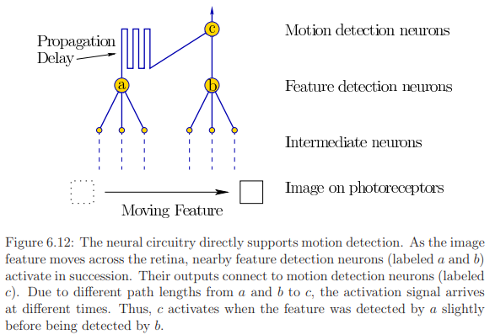
Figure 6.12 shows a feature moving from left to right. Suppose that a train of features moves from right to left. Based on the speed of the features and the spacing between them, the detector may inadvertently fire, causing motion to be perceived in the opposite direction. This is the basis of the wagon-wheel effect, for which a wheel with spokes or a propeller may appear to be rotating in the opposite direction, depending on the speed.
The process can be further disrupted by causing eye vibrations from humming.
Another point is that the motion detectors are subject to adaptation. Therefore, several illusions exist, such as the waterfall illusion and the spiral aftereffect, in which incorrect motions are perceived due to aftereffects from sustained fixation.
Waterfall illusion: While watching a waterfall the brain cells that detect downward motion become tired. When the eyes look away, the cells that detect upward motion are more active and a stationary object appears appear to be moving up.

From local data to global conclusions
Motion detectors are local in the sense that a tiny portion of the visual field causes each to activate. Aperture problem: Different directions of motion can appear identical when viewed through an aperture.
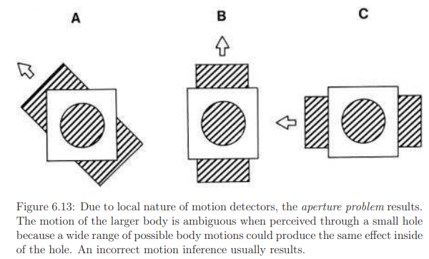
A clean mathematical way to describe the global motions across the retina is by a vector field, which assigns a velocity vector at every position. The global result is called the optical flow, which provides powerful cues for both object motion and self motion. The latter case results in vection, which is a leading cause of VR sickness.
Distinguishing object motion from observer motion
Figure 6.14 shows two cases that produce the same images across the retina over time. In Figure 6.14(a), the eye is fixed while the object moves by. In Figure 6.14(b), the situation is reversed: The object is fixed, but the eye moves. The brain uses several cues to differentiate between these cases.
Saccadic suppression hides vision signals during movements; this may suppress motion detectors in the second case. (When your eyes move, your brain purposely blocks your vision, which is why you can’t see the motion of your own eyes in the mirror. This is called saccadic masking. )
Another cue is provided by proprioception, which is the body’s ability to estimate its own motions due to motor commands. This includes the use of eye muscles in the second case.
Finally, information is provided by large-scale motion. If it appears that the entire scene is moving, then the brain assumes the most likely interpretation, which is that the user must be moving. This is why the haunted swing illusion is so effective.
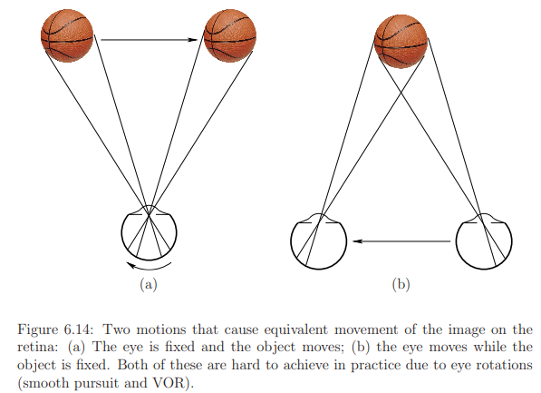
2.2.2 Stroboscopic apparent motion
The motions we see in TV are an illusion because a sequence of still pictures is being flashed onto the screen. This phenomenon is called stroboscopic apparent motion; it was discovered and refined across the 19th century.
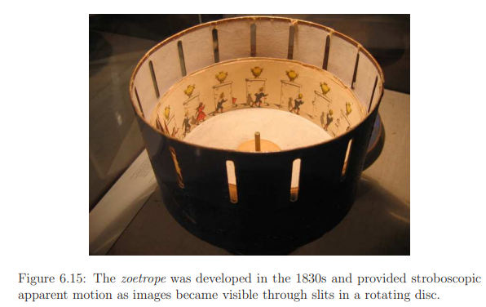
The zoetrope, shown in Figure 6.15 was developed around 1834. It consists of a rotating drum with slits that allow each frame to be visible for an instant while the drum rotates.
Illusion of motion work because of persistence of vision. The theory states that images persist in the vision system during the intervals in between frames, thereby causing them to be perceived as continuous. (Even after the object is removed, the impression of an object seen by the eye remains on the retina for 1/16th of a second).
One piece of evidence against this theory is that images persist in the visual cortex for around 100ms, which implies that the 10 FPS (Frames Per Second) is the slowest speed that stroboscopic apparent motion would work; however, it is also perceived down to 2 FPS.
Another piece of evidence against the persistence of vision is the existence of stroboscopic apparent motions. The phi phenomenon and beta movement are examples of motion perceived in a sequence of blinking lights, rather than flashing frames.
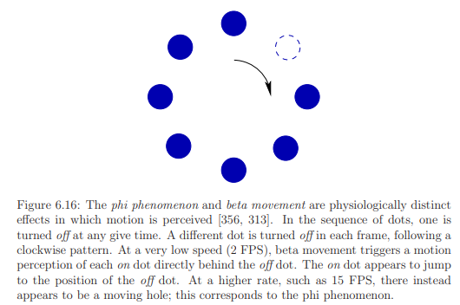
Frame rates
How many frames per second are appropriate for a motion picture? The answer depends on the intended use. Figure 6.17 shows a table of significant frame rates from 2 to 5000.
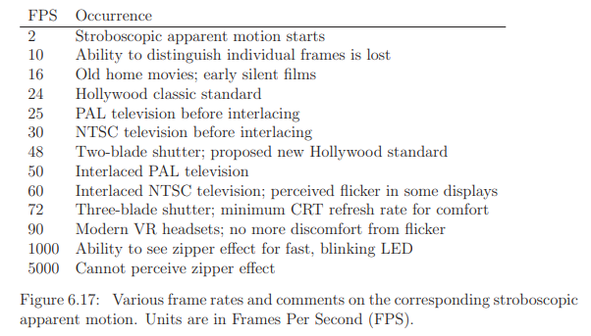
2.2.3 Implications for VR
VR systems require much higher display performance than usual. The next problem is that higher frame rates are needed in comparison to ordinary television or movie standards of 24 FPS or even 60 FPS.
To understand why, see Figure 6.18. The problem is easiest to understand in terms of the perception of stationarity. Fixate on a nearby object and yaw your head to the left. Your eyes should then rotate to the right to maintain the object in a fixed location on the retina, due to the VOR. If you do the same while wearing a VR headset and fixating on an object in the virtual world, then the image of the object needs to shift across the screen while you turn your head. Assuming that the pixels instantaneously change at each new frame time, the image of the virtual object will slip across the retina as shown in Figure 6.18. The result is a kind of judder in which the object appears to be wobbling from side to side with high frequency but small amplitude.
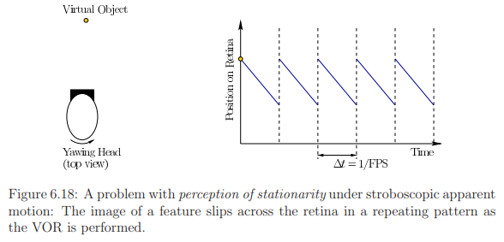
The problem is that each feature is fixed on the screen for too long when ideally it should be moving continuously across the screen. At 60 FPS, it is fixed for 16.67ms during each frame. If the screen is instead turned on for only one or two milliseconds for each frame, and then made black during the remaining times, then the amount of retinal image slip is greatly reduced. This display mode is called low persistence, and is shown in Figure 6.19(a).
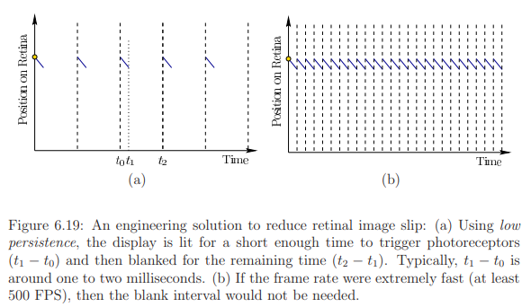
The short amount of time that the display is illuminated is sufficient for the photoreceptors to collect enough photons to cause the image to be perceived. The problem is that at 60 FPS in low-persistence mode, flicker is perceived, which can lead to fatigue or headaches. This can be easily perceived at the periphery in a bright scene in the Samsung Gear VR headset. If the frame rate is increased to 90 FPS or above, then the adverse side effects of flicker subside for nearly everyone. If the frame rate is increased to 500 FPS or beyond, then it would not even need to flicker, as depicted in Figure 6.19(b).
2.3 Perception of Color
What makes an object “purple”, “pink”, or “gray”? Color perception is purely the result of our visual physiology and neural structures, rather than something that can be measured in the physical world. In other words, “It’s all in your head.”
The dress
Figure 6.20 illustrates the dress color illusion. It was worn by Cecilia Bleasdale and became an Internet meme when millions of people quickly began to argue about the color of the dress. Based on the precise combination of colors and lighting conditions, its appearance fell on the boundary of what human color perceptual systems can handle. About 57% perceive it as blue and black (correct), 30% percent perceive it as white and gold, 10% perceive blue and brown, and 10% could switch between perceiving any of the color combinations.
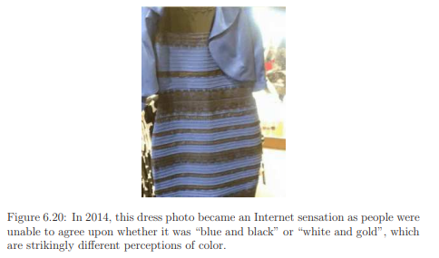
Dimensionality reduction
Light energy is a mix of wavelengths and magnitudes that form the spectral power distribution. A spectral power distribution (SPD) is a graph of the energy levels of a light source through a range of wavelengths of light.
Dimensionality reduction, or dimension reduction, is the transformation of data from a high-dimensional space into a low-dimensional space so that the low-dimensional representation retains some meaningful properties of the original data, ideally close to its intrinsic dimension.
Here, the infinite-dimensional space of power distributions of our eyes collapses down to a 3D color space.The engineered systems must be good enough to adequately fool our senses, but they need not have levels of quality that are well beyond the limits of our receptors.
Yellow = Green + Red
To help understand this reduction, consider the perception of “yellow”. According to the visible light spectrum ,yellow has a wavelength of about 580nm. Suppose we had a pure light source that shines light of exactly 580nm wavelength onto our retinas with no other wavelengths. The spectral distribution function would have a spike at 580nm and be zero everywhere else. If we had a cone with peak detection at 580nm and no sensitivity to other wavelengths, then it would perfectly detect yellow.

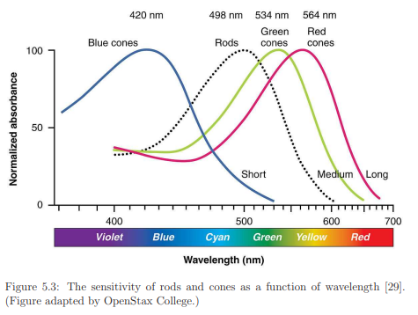
Instead, we perceive yellow by activation of both green and red cones because their sensitivity regions (Figure 5.3) include 580nm. It should then be possible to generate the same photoreceptor response by sending a jumble of light that contains precisely two wavelengths: 1) Some “green” at 533nm, and 2) some “red” at 564nm. If the magnitudes of green and red are tuned so that the green and red cones activate in the same way as they did for pure yellow, then it becomes impossible for our visual system to distinguish the green/red mixture from pure yellow. Both are perceived as “yellow”. This matching of colors from red, green and blue components is called metamerism.
Such a blending is precisely what is done on a RGB display to produce yellow. Suppose the intensity of each color ranges from 0 (dark) to 255 (bright). Red is produced by RGB= (255, 0, 0), and green is RGB= (0, 255, 0). These each activate one LED (or LCD) color, thereby producing a pure red or green. If both are turned on, then yellow is perceived. Thus, yellow is RGB= (255, 255, 0).
Color spaces For convenience, a parameterized color space is often defined. One of the most common in computer graphics is called HSV, which has the following three components (Figure 6.21):
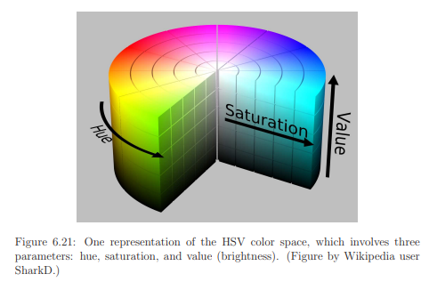
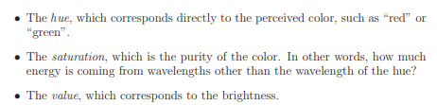
There are many methods to scale the HSV coordinates, which distort the color space in various ways. The RGB values could alternatively be used, but are sometimes more difficult for people to interpret.
It would be ideal to have a representation in which the distance between two points corresponds to the amount of perceptual difference. In other words, as two points are further apart, our ability to distinguish them is increased. The distance should correspond directly to the amount of distinguishability. Vision scientists designed a representation to achieve this, resulting in the 1931 CIE color standard shown in Figure 6.22.
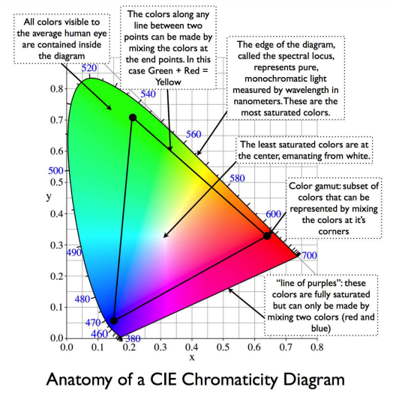
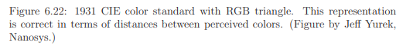
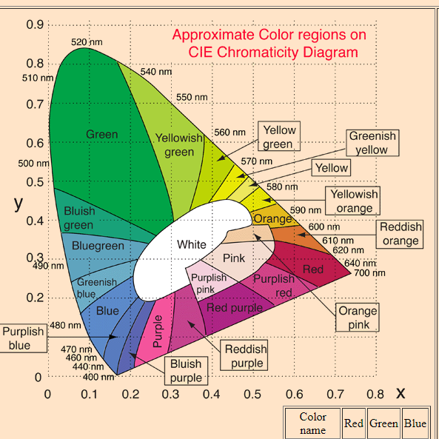
Mixing colors
In general, most perceptible colors can be matched by a mixture of three colors. This is called trichromatic theory (or Young-Helmholtz theory). A set of colors that achieves this is called primary colors. Mixing all three evenly produces perceived white light, which on a display is achieved as RGB= (255, 255, 255). Black is the opposite: RGB= (0, 0, 0). Such light mixtures follow a linearity property.
When mixing paints or printing books, colors mix subtractively because the spectral reflectance function is being altered. When starting with a white canvass or sheet of paper, virtually all wavelengths are reflected. Painting a green line on the page prevents all wavelengths other than green from being reflected at that spot. Removing all wavelengths results in black. Rather than using RGB components, printing presses are based on CMYK, which correspond to cyan, magenta, yellow, and black. The first three are pairwise mixes of the primary colors. A black component is included to reduce the amount of ink wasted by using the other three colors to subtractively produce black. Note that the targeted colors are observed only if the incoming light contains the targeted wavelengths. The green line would appear green under pure, matching green light, but might appear black under pure blue light.
Constancy
Our ability to perceive an object as having the same color over a wide variety of lighting conditions is called color constancy.
Color constancy refers to our ability to perceive colors as relatively constant over varying illuminations (i.e. light sources). For example, a red apple will still look red on a sunny day or cloudy day – or in a grocery store or a home.
Several perceptual mechanisms allow this to happen. One of them is chromatic adaptation, which results in a shift in perceived colors due to prolonged exposure to specific colors. Due to chromatic adaptation, a piece of paper will appear white whether it is being seen outdoor in daylight or indoor under artificial light.( the bright yellow petals of flowers will appear dark compared to the green leaves in dim light while the opposite is true during the day. ) Another factor in the perceived color is the expectation from the colors of surrounding objects. Furthermore, memory about how objects are usually colored in the environment biases our interpretation.
The constancy principle also appears without regard to particular colors. Our perceptual system also maintains lightness constancy so that the overall brightness levels appear to be unchanged, even after lighting conditions are dramatically altered; see Figure 6.23(a). Under the ratio principle theory, only the ratio of reflectances between objects in a scene are perceptually maintained, whereas the overall amount of reflected intensity is not perceived. Further complicating matters, our perception of object lightness and color are maintained as the scene contains uneven illumination. A clear example is provided from shadows cast by one object onto another. Our perceptual system accounts for the shadow and adjusts our perception of the object shade or color. The checker shadow illusion shown in Figure 6.23 is caused by this compensation due to shadows.
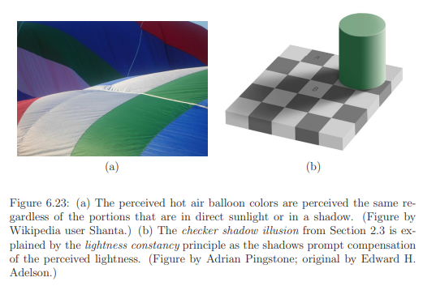
Display issues
Displays generally use RGB lights to generate the palette of colors and brightness. s. Usually, the intensity of each R, G, and B value is set by selecting an integer from 0 to 255. This is a severe limitation on the number of brightness levels. One cannot hope to densely cover all seven orders of magnitude of perceptible light intensity. One way to enhance the amount of contrast over the entire range is to perform gamma correction.
In most displays, images are encoded with a gamma of about 0.45 and decoded with a gamma of 2.2.
Another issue is that the set of all available colors lies inside of the triangle formed by R, G, and B vertices. This limitation is shown for the case of the sRGB standard in Figure 6.22. Most the CIE is covered, but many colors that humans are capable of perceiving cannot be generated on the display.
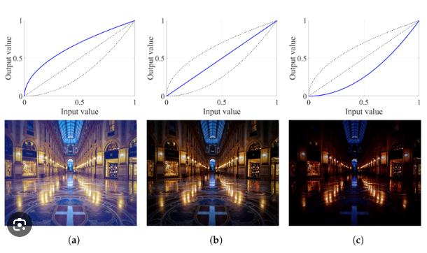
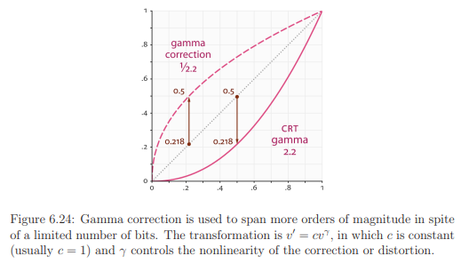
Gamma correction is a nonlinear operation for encoding and decoding luminance in video or digital images. It's used to properly display brightness on computer (and other digital display) screens. Gamma correction includes gamma encoding and gamma decoding.
Gamma Correction maps the linear intensities to a different representation that is finally perceived correctly.

https://www.irawen.com/2021/05/position-and-orientation-in-geometry-of.html
http://motion.pratt.duke.edu/RoboticSystems/3DRotations.html

Question Bank
- Explain about geometric models.(7 marks)

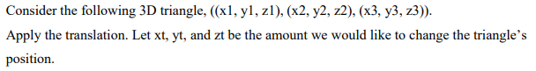
Answer

3.
Answer
Relativity

In Figure 3.4(b) the triangle is interpreted as having moved in the virtual world. However, Figure 3.4(c) shows another possibility: The coordinates of the virtual world have been reassigned so that the triangle is closer to the origin. This is equivalent to having moved the entire world, with the triangle being the only part that does not move. In this case, the translation is applied to the coordinate axes, but they are negated. Transforming the coordinate axes results in an inverse of the transformation that would correspondingly move the model. Negation is simply the inverse in the case of translation.
Thus, we have a kind of “relativity”: Did the object move, or did the whole world move around it?

4.
Answer
x_{t}=5
y_{t}=6
z_{t}=5
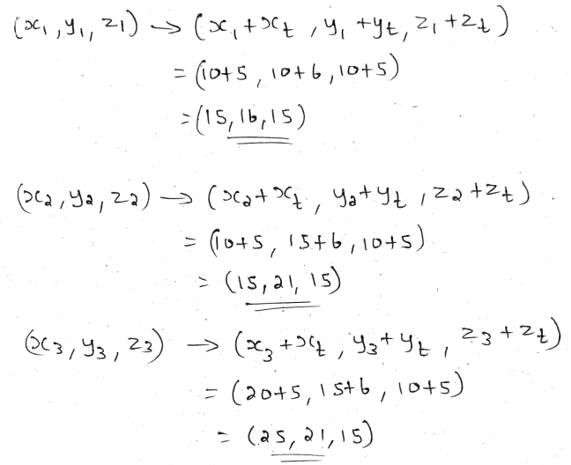
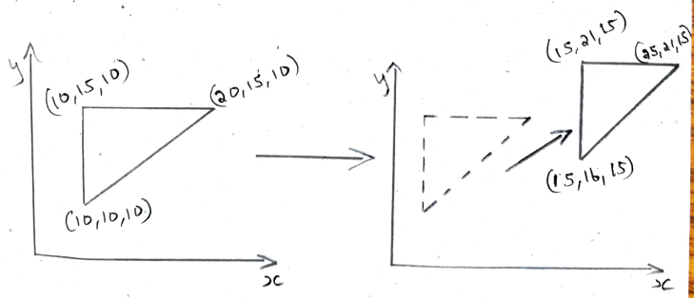
5. Illustrate with an example how a 2- dimensional matrix can be applied to points.
(7 marks)
6. Apply eight possible different 2-dimensional matrices to transform a square face.
(7 marks)
7.Apply eight possible various 2-dimensional matrices to transform a square face. How can you change the position and orientation of an object? (14 marks)
8. List out the advantages of using VR over traditional mediums like TV, movies or games
(7 marks)
- Immersion: VR provides a more immersive experience than traditional mediums by placing the user inside the virtual world. This allows for a deeper level of engagement and connection with the content.
- Interactivity: VR experiences are often more interactive than traditional mediums, allowing users to move around and interact with the environment in real time. This can lead to a more engaging and memorable experience.
- Presence: VR can create a sense of presence in the user, making them feel like they are actually in the virtual world. This can be useful for a variety of applications such as training, education and entertainment.
- Scalability: VR experiences can be scaled to any size, from small personal experiences to large scale simulations. This makes VR a versatile tool for a variety of applications.
- Cost effectiveness: VR technology is becoming increasingly affordable , making it more accessible to businesses and consumers. This means that VR can be used to create high-quality experiences at a relatively low cost.
9. Explain Perception of Depth? (14 marks)
10. Explain Perception of Motion? (14 marks)
11. Explain Perception of Color? (14 marks)

